Data Sheet

Product Name: Membrane Protein – Human Adult Normal Tissue: Breast

Catalog No.: P3234086 Lot No.: C204073

Species: Human Mouse Rat Monkey (Rh) Guinea Pig Porcine
Bovine Hamster Dog Monkey (Cy) Rabbit Plant

Tissue Type: Normal Adult Fetal Tumor Disease Cell Line

Donor Information:

Male: year(s) old Pool of donor(s)

Female: 62 year(s) old Pool of 1 donor(s)

Clinical Diagnosis: Normal

Packaging: 0.1 mg per vial; Concentration: 1.02 mg/ml.

Quality Control: Protein lysate is verified on SDS-PAGE comparing to standard protein lysate.

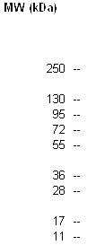

FOR IN VITRO RESEARCH USE ONLY APPROVED BY:

